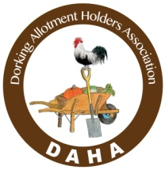
THE DORKING ALLOTMENTHOLDERS’ ASSOCIATION

13th ANNUAL MOLE VALLEY SQUASH AND PUMPKIN SHOW 2020

Sunday 11th October, Denbies Vineyard, London Rd, Dorking RH5 6AA

Show Schedule and Rules
NOTES FOR EXHIBITORS

Do not be put off by the rules but do read them! They are there to help you and make things fair.

Pumpkins are known as mature fruits, ripening to orange and with a hollow seed cavity which are often used for carving.
Winter squash are generally varieties whose fruits are eaten at the fully mature stage and which can be stored for winter use.
Summer squash are fruit eaten and shown at the immature stage but can still be entered for the show if available towards the end of the growing season.
Gourds are inedible fruits grown for their ornamental value.

Our judges will take account of form, maturity, colour and uniformity. The stalk or peduncle should be retained and all exhibits should be clean.
Weighing scales will be available at the Show to help Exhibitors decide which Classes to enter and the Show Organisers are happy to offer further help and advice.

TROPHIES AND PRIZES

Rob Arthur Trophy; awarded to the biggest pumpkin or squash by weight
(class 13).
Mole Valley District Council ‘Best in Show’ Trophy; awarded to the best exhibit in categories A-E.
Arts Alive Trophy; awarded to the best exhibit in the Arts Alive Category
Boothole Trophy; awarded to the child with the most points in the Junior Category.
Pumpkin Pie Trophy; awarded to the person with the most points in the Culinary category.
Alaster Calder Gourd Bowl; awarded to the person with the most points in the Gourds Category.
School’s Trophy; awarded to the school with the best display.
Butternut Trophy; awarded to the person with the most points in this NEW catergory.
Banksian Medal; for the highest total number of points awarded in categories A – E.
(Please note that except for the Banksian Medal the above Trophies are awarded for one year and must be returned by the Pumpkin Show next year)

PROGRAMME

Sunday 11th October - Halls open from 8am-11am for exhibitors to bring entries for weighing.
Judging – 11-12.30
13.00 – 4.30pm - Show will be open to the public.

RULES

1. Categories F, G, H and I are open to all members of the public for free. Categories A-E are free to enter for all members of the Dorking Allotment Holders Association and their families. For non-members there is a £1 fee for each entry.
2. The rules wherever possible, will be based on the RHS ‘Horticultural Show Handbook’ (classes A-E)
3. Exhibits are limited to pumpkins, squashes (both summer and winter) and gourds and must have been grown by the Exhibitor for at least 3 months prior to the Show.
4. Exhibitors may enter only one Exhibit per Class. No two persons may compete in the same Class with produce from the same garden or allotment (except Sections H & I).
5. An Exhibit may only be moved at the discretion of the Show Organiser.
6. The Judges’ decision shall be final in respect of the merits of the Exhibits. The Committees decision shall be final regarding the organization of the Show.
7. Each Exhibit must be accompanied by an entry card (available on the day) with the entry class clearly identified. Exhibitors are responsible for the delivery and collection of their Exhibits. Exhibits may be brought to the show between 18.00 and 21.00 on Friday 11th October and between 09.00 and 11.00 on the day of the Show.
8. Exhibits must remain in the hall until 17.00. Exhibits may be collected from the hall between 17.00 and 18.00. Any exhibits remaining after this time will be assumed to have been donated to DAHA.

SCHEDULE OF CLASSES

A: SMALL CATEGORY (each pumpkin or squash up to 1.5kg)

1. Single pumpkin or squash.
2. Three pumpkins or squash – same variety.
3. Three pumpkins or squash – mixed varieties.

B: MEDIUM CATEGORY (each pumpkin or squash 1.5kg to 3kg)

4. Single pumpkin or squash – any variety.
5. Three pumpkins or squash – same variety.
6. Three pumpkins or squash – mixed varieties.

C: LARGE CATEGORY (each pumpkin or squash over 3kg)

7. Single pumpkin or squash.
8. Pair of pumpkin or squash – same variety.
9. Three pumpkin or squash - mixed varieties.
10. Three pumpkin or squash – same variety.
11. Biggest pumpkin or squash (by weight).
12. Ugliest pumpkin or squash.

D: BUTTERNUT SQUASH CATEGORY

13. Single butternut squash.
14. Two butternut squash.
15. An arrangement of three butternuts – any size or weight.

E: GOURDS CATEGORY

16. Single gourd.
17. Pair of gourds –same variety.
18. Three gourds –mixed varieties.
19. A basket of 5 gourds – any variety.

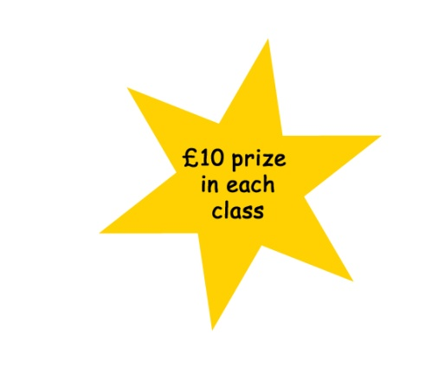
F: JUNIOR CATEGORY (16 years or under) (judged by quality of fruit)

20. A single squash, pumpkin or gourd under 1.5kg.
21. A single squash, pumpkin or gourd over 1.5kg, under 3kg.
22. A single squash, pumpkin or gourd over 3kg.

G: JUNIOR GROUP CATEGORY (open to schools, scout and guide groups etc), (16 years and under)

23. The largest (by weight) collection of multiple varieties of pumpkins, squash or gourds grown by members of the group at home, allotment or at the group’s premises.

24. An arrangement of pumpkins squash or gourds grown at school or at home by the pupils to fit on a table approximately 900x780mm. Produced by the Children.

H: SQUASH COOK-OFF CATEGORY (Ingredients may be shop bought)

25. A bowl of pumpkin/squash soup.
26. Three individual tarts, cakes or puddings containing pumpkin.
27. One portion of a savoury pumpkin/squash dish.
28. A jar of homemade pumpkin jam, chutney or preserve. (unopened)

I: ARTS ALIVE CATEGORY (inspired by the world of pumpkin and squash)

29. A single photograph.
30. A decorative arrangement incorporating three pumpkins, squash or gourds.
31. A single painting or drawing using any medium.
32. A sculpture or creation using any materials.
33. A carved or decorated pumpkin, squash or gourd

